Electric Vehicle Market Segmentation

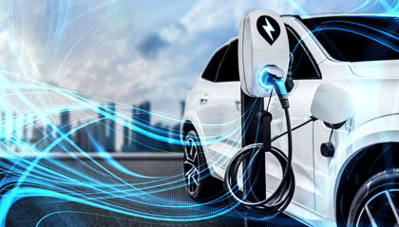

GitHub Link (Dataset and Code)

**AUTHOR**

SANDEEP GHODESWAR

**Overview**

The project aims to perform market segmentation for the electric vehicle (EV) market. Market segmentation involves dividing a broad market into distinct groups of consumers with similar characteristics and needs. By segmenting the EV market, we can gain valuable insights into different customer segments and tailor marketing strategies accordingly.

# Problem Statement

We are a team working under an Electric Vehicle Startup. We have to decide which vehicle/customer space should be considered by the startup to develop its EVs.

We have to analyse the Electric Vehicle market in India using Segmentation analysis and come up with a feasible strategy to enter the market, targeting the segments most likely to use Electric vehicles.

# Data Sources

**Dataset 1:** <https://electricvehicles.in/electric-vehicles-sales-report-in-india-2018/> : For

region-based analysis of different types of Electric Vehicle sales in India for the year 2018.

**Dataset 2:** <https://www.kaggle.com/karivedha/indian-consumers-cars-purchasing-behaviour>

: For behavioural, psychographic and demographic analysis of Indian automobile market.

# Data Preprocessing

## Libraries Used

NumPy : Scientific Computing Library Pandas : Data Analysis Library

Matplotlib : Data Visualization Library Seaborn : Data Visualization Library

Scikit-Learn : Machine Learning Library

## Steps

**Behavioural and Psychographic Analysis**

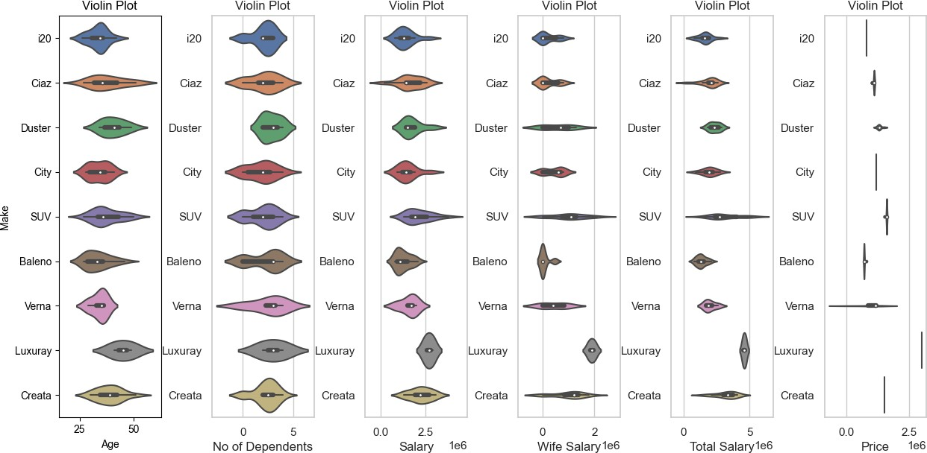

## Relation between consumers' total salary and the vehicles they tend to purchase

**Demographic Analysis**

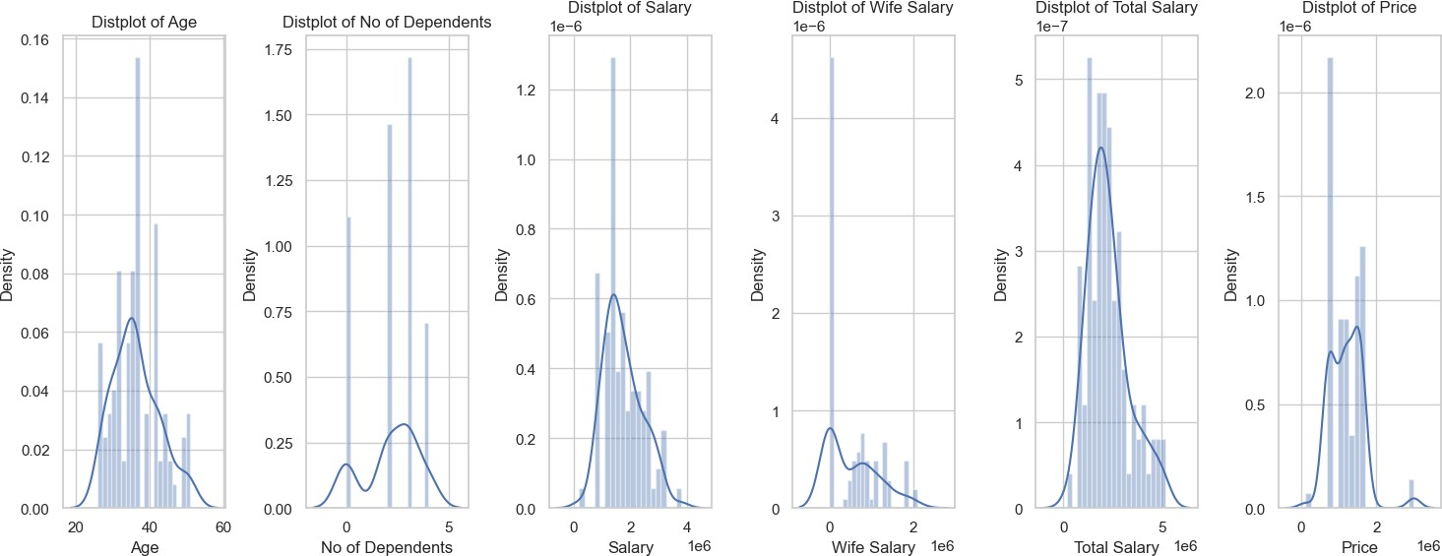

## Heatmap of Correlation

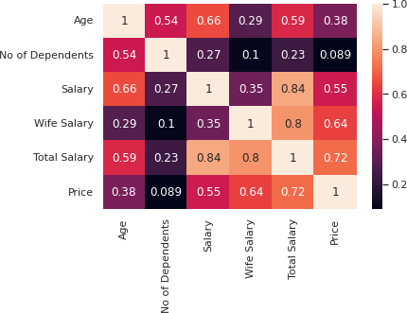

**Pair Plot**

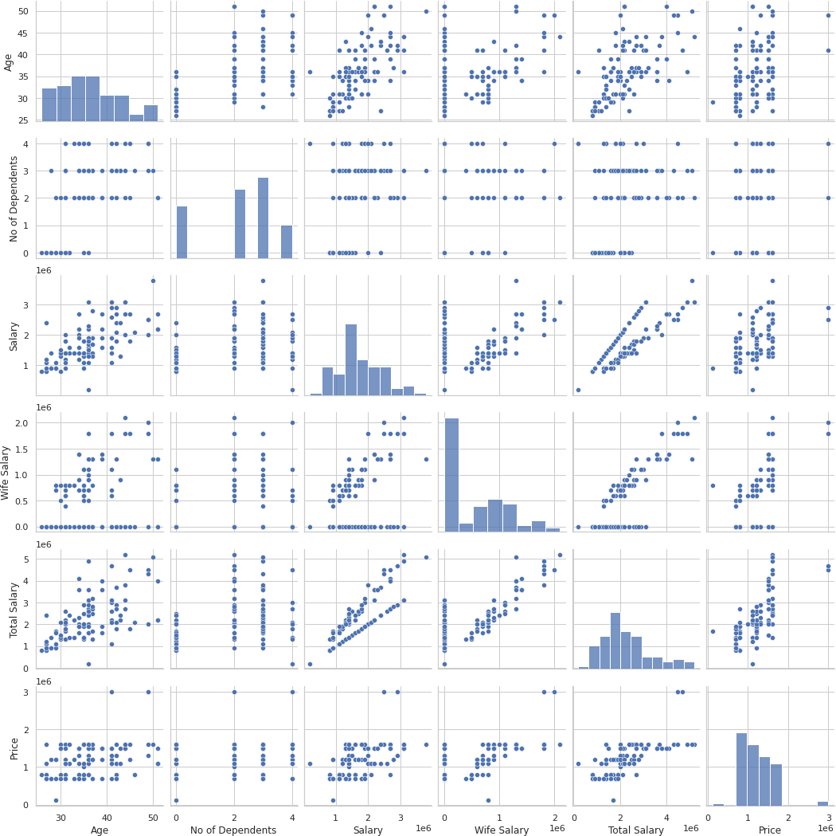

**Geographic Analysis**

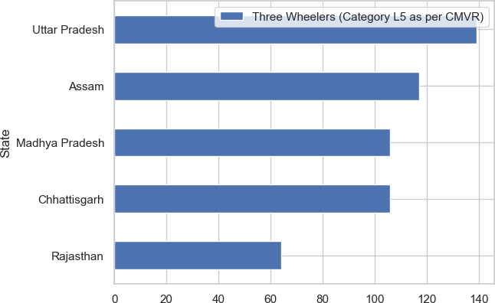

# 4. Segment Extraction

## K-Means Clustering

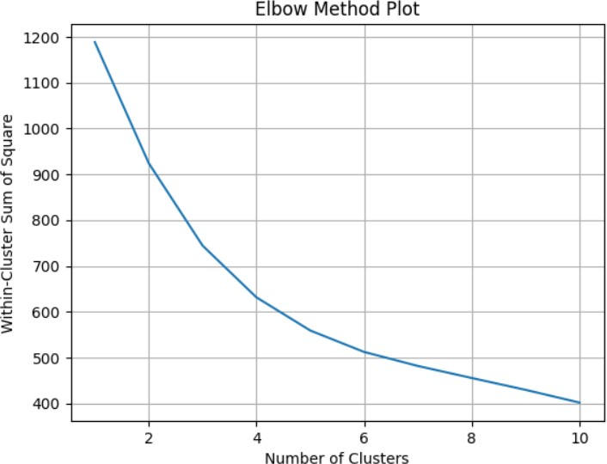

**Number of Clusters =3**

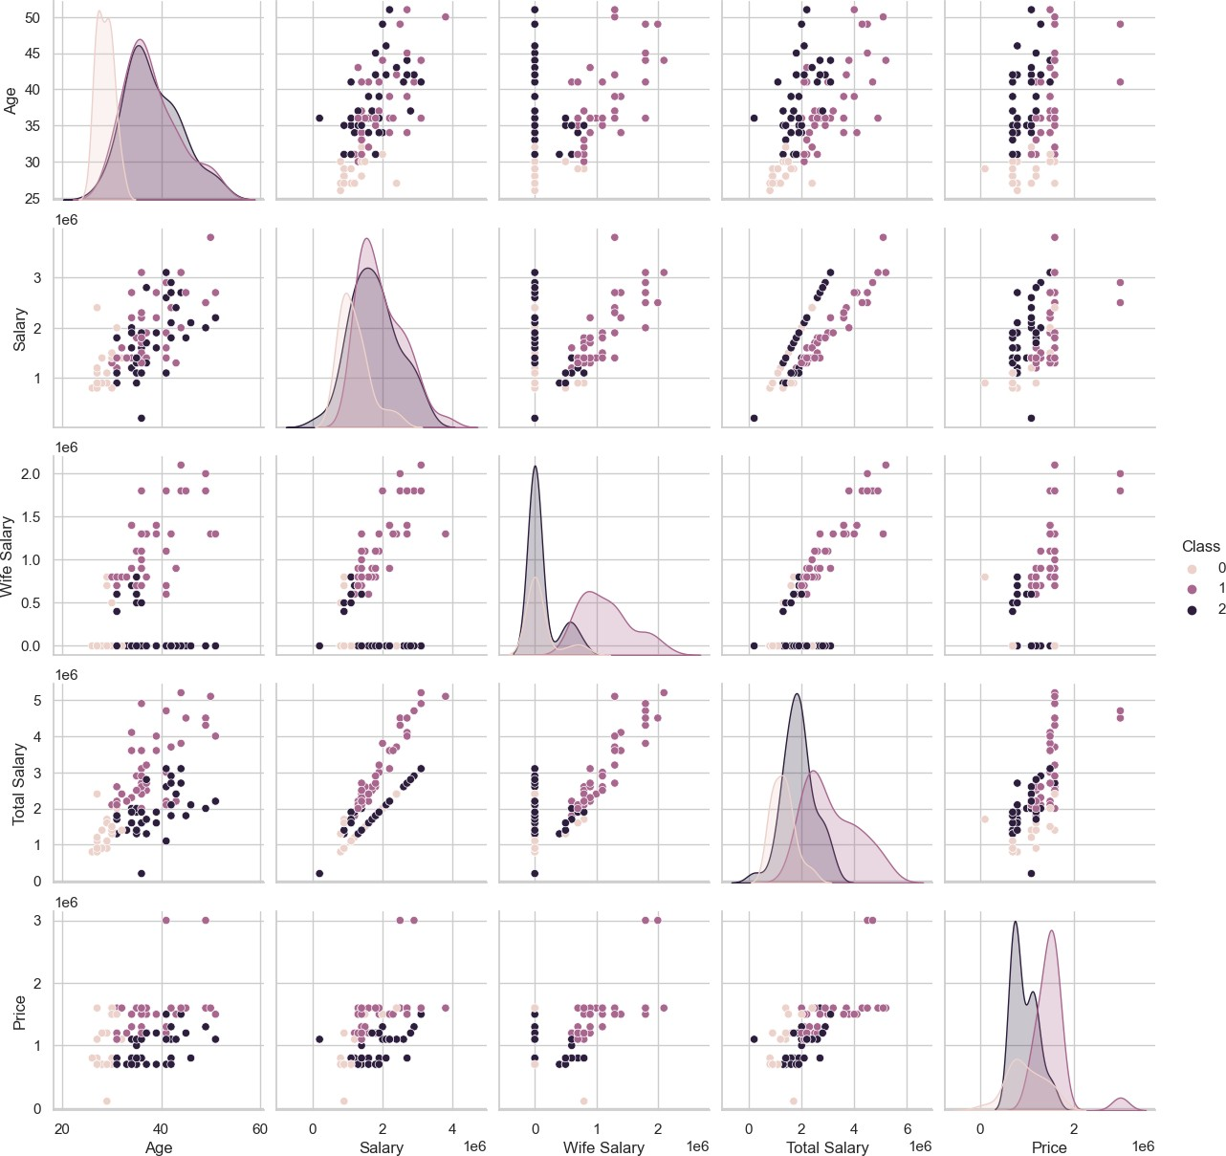

**Number of Clusters =5**

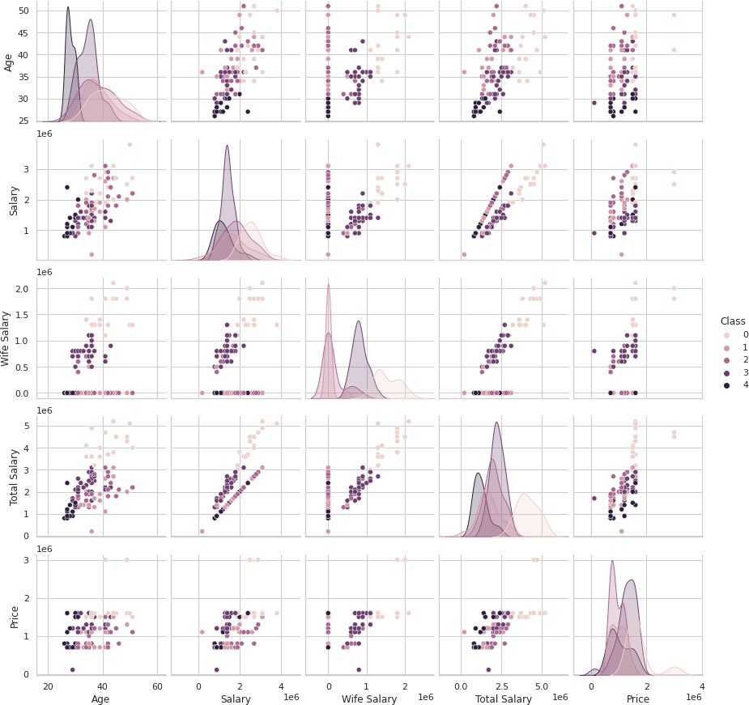

# Selection of Target Segment

The younger population is more likely to purchase products with new technology, especially Electric Vehicles as they are aware of the environmental benefits and would like to bring that change, but our report showed that younger population buys less expensive vehicles and so Electric Vehicles not being affordable can be a downside. It is then suggested to target a segment which is still eager to try new technologies but financially well enough to be able to afford Electric Vehicles. These people are likely to be in an age-group of 30 to 40 years.

People from urban cities with available infrastructure and education about technology and its benefits will tend to purchase electric vehicles more.

People who are married and who have dependents are more likely to go ahead and purchase a vehicle and so they could be targeted.

Average salary of people who buy vehicles is around 30 lakh and the most purchases for automobiles lies in the range 10-20 lakh and lesser for two-wheelers. These aspects need to be kept in mind too.

# Customizing the Marketing Mix

Setting prices for our products is both an art and a science. Most importantly, you must know and understand your cost of production. From there you can adjust based on product characteristics, a specific pricing strategy, customer price sensitivity, customer values, and other factors. Marketing Mix helps understand what our product or service can offer to our customers and helps plan a successful product offering. Helps with planning, developing and executing effective marketing strategies. Help determine whether your product or service is suitable for your customers.



## PRODUCT

The type of product would obviously depend on the EV Startup, but throughout our analysis we figured that for India it is best to enter the market with two-wheelers because the most automobile market-share is of two-wheelers. Most people would purchase a two-wheeler because it is cost effective, and the current infrastructure would support that.

Another type of product EV Startup can look into is public transport vehicles, because the current government policies are supportive for revamping public transport to electric-based engines.

## PRICE

Affordability is a major issue with the growth of Electric Vehicles. It is important to keep in mind that in order to appeal to the consumers, the company’s product has to be cost

effective to both purchase and maintain. The product’s price should ideally range between 10 to 20 lakhs, as most people would make a purchase in this range.

## PLACE

Infrastructure is another important aspect that has to be kept in mind while creating any product and launching it. Major urban cities of the country should be targeted as these are the places where infrastructure would support. Another reason for targeting urban cities is that here it is more likely to have an educated population willing to buy Electric Vehicles because they are aware of the environmental benefits.

For different types of vehicles, the list of top states which will promise a good market have been given in our geographical analysis.

## PROMOTION

Promotion is product dependent. The best possible promotion is to educate people of the benefits of EV/HEV/PHEV over fuel-based vehicles. If the Startup comes up with an affordable product that should definitely be promoted.